Popular Spend Analysis Report Templates

Basic Reports

Total Spend by Business Unit
Shows the percentage of spend represented by each included business unit.

Total Spend by Quarter
Shows spend increases and decreases as a trend over time.

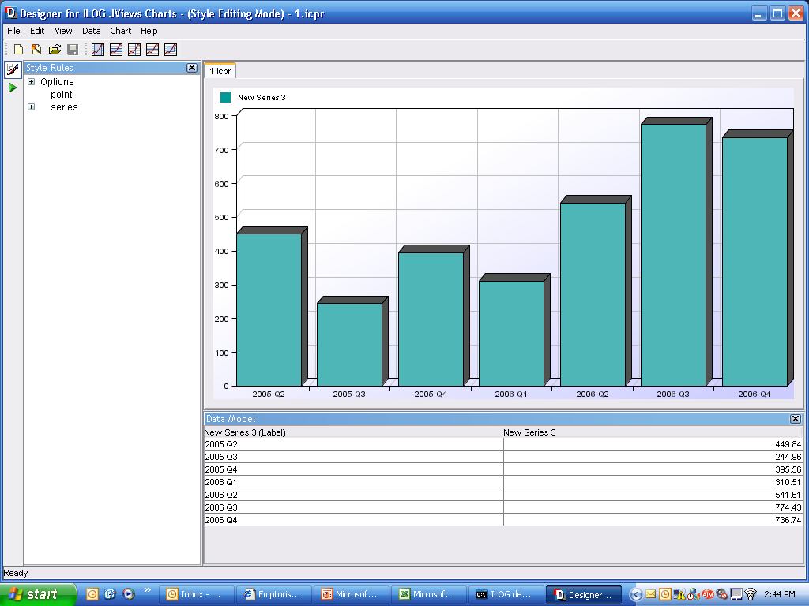

Quarterly Spend by Category
Compares the breakdown of spend into the highest level of the category structure. Each quarter is represented separately so that spending trends by category can be seen over time.

Top Vendors by Spend
This table shows the top thirty vendors by spend for the time scope of the report. Strategic vendors are flagged.

Strategic Vendor | Vendor Name | Spend ( $ ) | % Total | Total Spend | % Spend
Yes | Vendor 1 | 344,205,384 | 24.76% | 462,879,266 | 74.36%
No | Vendor 2 | 148,666,809 | 10.70% | 402,859,227 | 36.90%
Yes | Vendor 3 | 126,525,516 | 9.10% | 372,037,120 | 34.01%
No | …. | 122,798,604 | 8.83% | 344,205,524 | 35.68%
No | …. | 122,600,000 | 8.82% | 303,543,221 | 40.39%
No | …. | 83,484,373 | 6.01% | 274,181,808 | 30.45%
No | ….. | 73,959,558 | 5.32% | 176,525,516 | 41.90%
Yes | Vendor 30 | 2,033,725 | 0.15% | 11,628,493 | 17.49%

Spend by All Levels of the Commodity Structure
For each business unit, this table shows total spend at each level of the commodity structure for each quarter within the time scope of the report, and totaled for any complete years included.

Advanced Reports

Commodity Supplier Rationalization

Spend Concentration Report

Spend Concentration Report - 2006
2006 Goal - 90% Spend with 10% or less active suppliers
Commodity | Technology | Facilities | Professional Services | Marketing | Human Resources | Supplies | Capital Equipment
Spend in USD ($) | 799,774,693 | 599,475,251 | 408,785,354 | 230,534,217 | 225,090,748 | 201,236,608 | 190,608,135
# of Suppliers | 338 | 264 | 182 | 43 | 179 | 351 | 406
# suppliers accounting for 90% spend | 62.699 | 14.3352 | 19.656 | 10.5608 | 15.6983 | 52.4043 | 31.7492
% suppliers accounting for 90% spend | 18.55 | 5.43 | 10.8 | 24.56 | 8.77 | 14.93 | 7.82
Variance from Goal | -8.55 | 4.57 | -0.8 | -14.56 | 1.23 | -4.93 | 2.18

Sample Dashboards

Indirect Spend Opportunity Dashboard

Category Opportunity Dashboard

