INNOVATIONS R US CORPORATION – VALUE MAXIMIZATION USING PORTFOLIO OPTIMIZATION
Innovations R Us Corporation (The Corporation) has a portfolio of 10 projects (A-J) that it would like to invest in. Unfortunately, because of constrained budgetary and human resources, The Corporation cannot pursue all of its projects and therefore needs to select the best combination of projects that maximizes economic value – measured in the form of NPV – without exceeding any of its constraints. As described in Chapter 7, this combination of projects must lie on the Efficient Frontier i.e. yields maximum NPV for a given level of constrained resource. As Table 7-1 shows, if The Corporation had the necessary budgetary ($2.555B) and human resources (68 discoverers; 60 developers), it could realize $6.245B in NPV.
PROJECT | DECISION VARIABLES  Y = 1; N = 0 | DISCOVERERS  REQUIRED | DEVELOPERS  REQUIRED | INVESTMENT  REQUIRED ($M) | FORECASTED NPV ($M)
A | 1 | 7 | 4 | 250 | 650
B | 1 | 6 | 5 | 175 | 550
C | 1 | 9 | 6 | 300 | 600
D | 1 | 8 | 8 | 400 | 895
E | 1 | 9 | 7 | 500 | 900
F | 1 | 6 | 6 | 150 | 550
G | 1 | 5 | 5 | 150 | 450
H | 1 | 6 | 2 | 145 | 375
I | 1 | 4 | 8 | 160 | 525
J | 1 | 8 | 9 | 325 | 750
TOTAL |  | 68 | 60 | 2555 | 6245
CONSTRAINT |  | 45 | 40 | 1500

Table 7-1 Innovations R Us Corporation: unconstrained portfolio of 10 projects (Excel file: Innovations R Us Corporation; Tab 1)
Since The Corporation is constrained by budget ($1.500B) and human resources (45 discoverers; 40 developers), how can it find the best combination of projects that maximizes total portfolio NPV?
Using Frontline’s Premium Solver software, one can set up a simple linear program as shown in Table 7-2 and Figure 7-1. In Tab 2 of the Excel file: Innovations R Us Corporation, cell F12 is set to maximize the objective (NPV) while cells B2:B11 represent the decision variables or projects that may be included in the optimal portfolio. Likewise, cells C13:E13 represent the organization’s constraints that cannot be violated in the search for the optimal portfolio. Finally, the decision variables B2:B11 are represented as binary integers.

PROJECT | DECISION VARIABLES  Y = 1; N = 0 | DISCOVERERS  REQUIRED | DEVELOPERS  REQUIRED | INVESTMENT  REQUIRED ($M) | FORECASTED NPV ($M)
A | 1 | 7 | 4 | 250 | 650
B | 1 | 6 | 5 | 175 | 550
C | 1 | 9 | 6 | 300 | 600
D | 1 | 8 | 8 | 400 | 895
E | 1 | 9 | 7 | 500 | 900
F | 1 | 6 | 6 | 150 | 550
G | 1 | 5 | 5 | 150 | 450
H | 1 | 6 | 2 | 145 | 375
I | 1 | 4 | 8 | 160 | 525
J | 1 | 8 | 9 | 325 | 750
TOTAL |  | 68 | 60 | 2555 | 6245
CONSTRAINT |  | 45 | 40 | 1500

Table 7-2 Innovations R Us Corporation: linear program of unconstrained portfolio of 10 projects (Excel file: Innovations R Us Corporation; Tab 2)
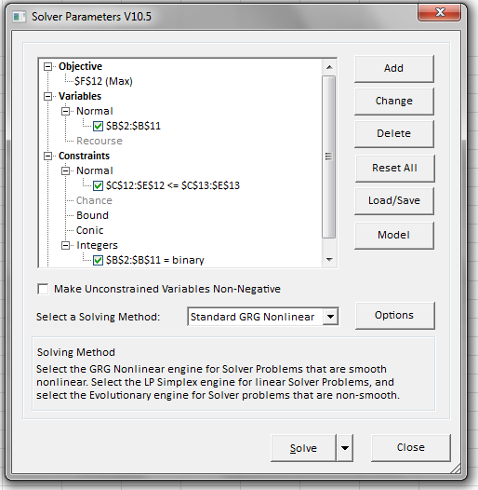
Figure 7-1 Innovations R Us Corporation: linear program of unconstrained portfolio of 10 projects (Excel file: Innovations R Us Corporation; Tab 2)
The linear program is now set to be run and the results are displayed in Table 7-3. Of the 10 projects in The Corporation’s portfolio, 7 are selected and constitute the optimal portfolio. Note that none of the constraints are violated and projects C,E,J are deselected from the portfolio yielding an aggregate NPV of $3.995B (Tab 3 of the Excel file: Innovations R Us Corporation).
PROJECT | DECISION VARIABLES  Y = 1; N = 0 | DISCOVERERS  REQUIRED | DEVELOPERS  REQUIRED | INVESTMENT  REQUIRED ($M) | FORECASTED NPV ($M)
A | 1 | 7 | 4 | 250 | 650
B | 1 | 6 | 5 | 175 | 550
C | 0 | 9 | 6 | 300 | 600
D | 1 | 8 | 8 | 400 | 895
E | 0 | 9 | 7 | 500 | 900
F | 1 | 6 | 6 | 150 | 550
G | 1 | 5 | 5 | 150 | 450
H | 1 | 6 | 2 | 145 | 375
I | 1 | 4 | 8 | 160 | 525
J | 0 | 8 | 9 | 325 | 750
TOTAL |  | 42 | 38 | 1430 | 3995
CONSTRAINT |  | 45 | 40 | 1500

Table 7-3 Innovations R Us Corporation: linear program of constrained portfolio of 10 projects (Excel file: Innovations R Us Corporation; Tab 3)
Since project E has the highest forecasted NPV, The Corporation may not wish to forego this opportunity but, before making the decision to include it as a requirement (and, in effect, a constraint), the organization should examine the impact to the aggregate NPV if this project were selected as a part of the portfolio solution. To achieve this, one would simply add project E as a constraint to the linear program by making cell B6 = 1 as shown in Figure 7-2 and Table 7-4 (Tab 4 of the Excel file: Innovations R Us Corporation). Upon re-optimization with this additional requirement to force project E into the portfolio solution, the aggregate NPV is now $3.725B. Note that while project E is selected, projects A, C, D, H are now de-selected. As discussed in Chapter 7, forcing project E into the portfolio results in a loss of $3.995 - $3.725B or $270M. This may be perfectly acceptable to The Corporation but, without knowing how much value is foregone by the forced inclusion of project E, one would not be making an informed decision. Clearly, if the value lost from the portfolio by including project E is unacceptably high, The Corporation may not wish to force its inclusion into the portfolio any longer.

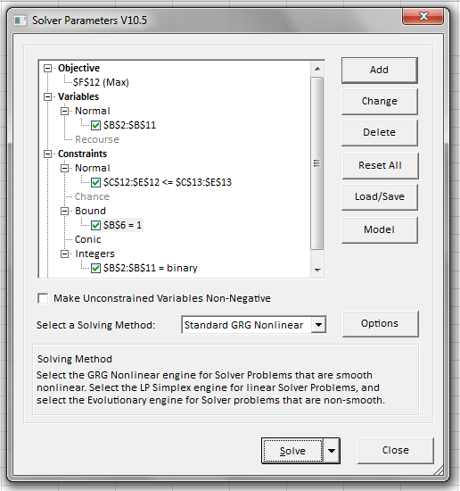
Figure 7-2 Innovations R Us Corporation: linear program of constrained portfolio of 10 projects with forced inclusion of project E (Excel file: Innovations R Us Corporation; Tab 4)
PROJECT | DECISION VARIABLES  Y = 1; N = 0 | DISCOVERERS  REQUIRED | DEVELOPERS  REQUIRED | INVESTMENT  REQUIRED ($M) | FORECASTED NPV ($M)
A | 0 | 7 | 4 | 250 | 650
B | 1 | 6 | 5 | 175 | 550
C | 0 | 9 | 6 | 300 | 600
D | 0 | 8 | 8 | 400 | 895
E | 1 | 9 | 7 | 500 | 900
F | 1 | 6 | 6 | 150 | 550
G | 1 | 5 | 5 | 150 | 450
H | 0 | 6 | 2 | 145 | 375
I | 1 | 4 | 8 | 160 | 525
J | 1 | 8 | 9 | 325 | 750
TOTAL |  | 38 | 40 | 1460 | 3725
CONSTRAINT |  | 45 | 40 | 1500

Table 7-4 Innovations R Us Corporation: linear program of constrained portfolio of 10 projects with forced inclusion of project E (Excel file: Innovations R Us Corporation; Tab 4)
One can examine a rather common portfolio situation where there are commercial dependencies between projects. As described in Chapter 7, projects D and C may be commercially dependent in that the viability of project D is dependent on the availability of project C (without the converse being true). In addition, projects B and I may compete for the same market segment so The Corporation may wish to select only one, but not both, of these projects. The linear program in Table 7-5 and Figure 7-3 (Tab 5 of the Excel file: Innovations R Us Corporation) now shows the binary integer logic that is used to accommodate these requirements (constraints) in cells A15:B16. Note that in this exercise, project E is no longer a requirement of the optimal portfolio. The optimal portfolio with these 2 commercial constraints yields an aggregate NPV of $3.900B with the exclusion of projects B,D,E.
PROJECT | DECISION VARIABLES  Y = 1; N = 0 | DISCOVERERS  REQUIRED | DEVELOPERS  REQUIRED | INVESTMENT  REQUIRED ($M) | FORECASTED NPV ($M)
A | 1 | 7 | 4 | 250 | 650
B | 0 | 6 | 5 | 175 | 550
C | 1 | 9 | 6 | 300 | 600
D | 0 | 8 | 8 | 400 | 895
E | 0 | 9 | 7 | 500 | 900
F | 1 | 6 | 6 | 150 | 550
G | 1 | 5 | 5 | 150 | 450
H | 1 | 6 | 2 | 145 | 375
I | 1 | 4 | 8 | 160 | 525
J | 1 | 8 | 9 | 325 | 750
TOTAL |  | 45 | 40 | 1480 | 3900
CONSTRAINT |  | 45 | 40 | 1500
If D, then C | -1
B or I | 1

Table 7-5 Innovations R Us Corporation: linear program of constrained portfolio of 10 projects with commercial requirements placed on projects D & C and projects B & I (Excel file: Innovations R Us Corporation; Tab 5)

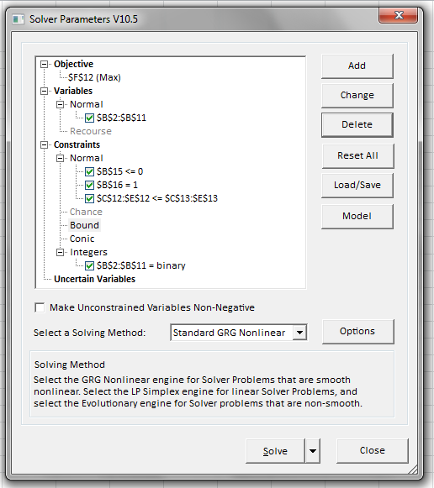
Figure 7-3 Innovations R Us Corporation: linear program of constrained portfolio of 10 projects with commercial requirements placed on projects D & C and projects B & I (Excel file: Innovations R Us Corporation; Tab 5)
Finally, if one adds the previous requirement to have project E as a selected project within the optimal portfolio, as shown in Chapter 7, one would expect the aggregate NPV to be less than $3.900B. This is indeed the situation as shown in Figure 7-4 and Table 7-6 (Tab 6 of the Excel file: Innovations R Us Corporation).
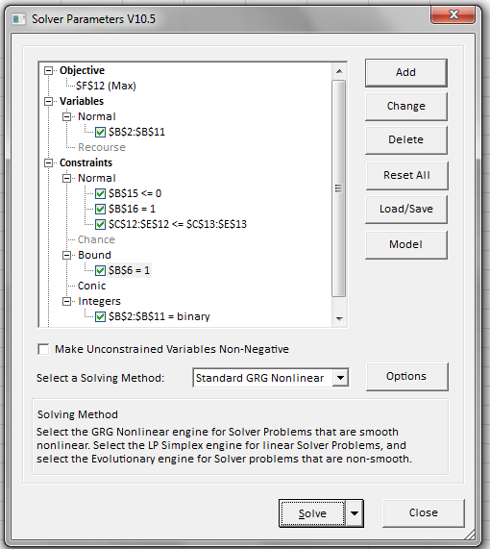
Figure 7-4 Innovations R Us Corporation: linear program of constrained portfolio of 10 projects with commercial requirements placed on projects D & C and projects B & I and inclusion of project E (Excel file: Innovations R Us Corporation; Tab 6)
PROJECT | DECISION VARIABLES  Y = 1; N = 0 | DISCOVERERS  REQUIRED | DEVELOPERS  REQUIRED | INVESTMENT  REQUIRED ($M) | FORECASTED NPV ($M)
A | 0 | 7 | 4 | 250 | 650
B | 1 | 6 | 5 | 175 | 550
C | 0 | 9 | 6 | 300 | 600
D | 0 | 8 | 8 | 400 | 895
E | 1 | 9 | 7 | 500 | 900
F | 1 | 6 | 6 | 150 | 550
G | 1 | 5 | 5 | 150 | 450
H | 1 | 6 | 2 | 145 | 375
I | 0 | 4 | 8 | 160 | 525
J | 1 | 8 | 9 | 325 | 750
TOTAL |  | 40 | 34 | 1445 | 3575
CONSTRAINT |  | 45 | 40 | 1500
If D, then C | 0
B or C | 1

Table 7-6 Innovations R Us Corporation: linear program of constrained portfolio of 10 projects with commercial requirements placed on projects D & C and projects B & I and inclusion of project E (Excel file: Innovations R Us Corporation; Tab 6)

