DRUGS R US – STRATEGY SELECTION USING DECISION TREE ANALYSIS
Drugs R Us has discovered two new, related molecular entities with a novel mechanism of action that may have therapeutic utility in two major diseases of the Central Nervous System (CNS): Alzheimer’s Disease (AD) and Generalized Anxiety Disorder (GAD). The company does not have a successful history in the development of drugs for CNS disorders but is acutely aware of the huge commercial potential for novel therapies in both diseases. Amongst the strategic alternatives available to Drugs R Us, senior management has narrowed its decision-making down to 2 attractive options: (a) Strategy A – develop the lead entity for AD alone at a cost of $350M without investing in the back-up molecule and (b) Strategy B – develop the lead entity for AD and the back-up entity for GAD at a combined cost of $625M.
There are both risks (e.g. probabilities of technical and regulatory success of both entities in AD and GAD) and uncertainties (e.g. ranges of commercial success of both entities in AD and GAD) that make the choice of strategy difficult without the aid of an analytic tool. Consequently, Drugs R Us has elected to use Decision Tree analysis to aid in the decomposition of the strategies so that an informed decision can be made on the basis of an integrated evaluation using expected (risk-adjusted) NPV (hereafter referred to as ENPV). The data and information for both strategies are captured in Table 13-1.
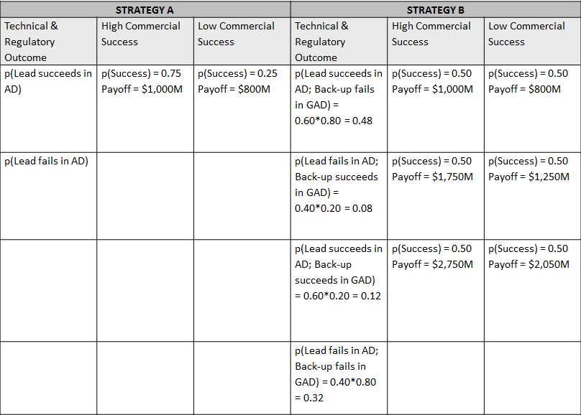
Table 13-1 Technical and regulatory risks and commercial uncertainties associated with the pursuit of Strategy A (lead entity in pursuit of AD alone) and Strategy B (lead entity in pursuit of AD and back-up entity in pursuit of GAD)
In Strategy A, the p(Technical & Regulatory Success) of the lead entity in AD is 0.60 and, if it is successful, there are 2 likely commercial outcomes – a high payoff of $1,000M with a probability of 0.75 and a low payoff of $800M with a probability of 0.25. In Strategy B, there are 4 mutually exclusive and collectively exhaustive technical and regulatory outcomes: (a) the lead entity succeeds in AD but the back-up fails in GAD (joint p(Success)) = 0.48, (b) the lead fails in AD but the back-up entity succeeds in GAD (joint p(Success = 0.08)), (c) the lead entity succeeds in AD and the back-up succeeds in GAD (joint p(Success = 0.12)), and (d) both lead and back-up entities fail in AD and GAD respectively (joint p(Success = 0.32)). The commercial payoffs and their associated probabilities of occurrence are shown in columns 5 & 6 of Table 13-1.
Using TreePlan software, a Decision Tree was constructed to represent the costs, risks, and uncertainties associated with both strategies (Figure 13-1; Excel file: Drugs R Us; Tab 1).
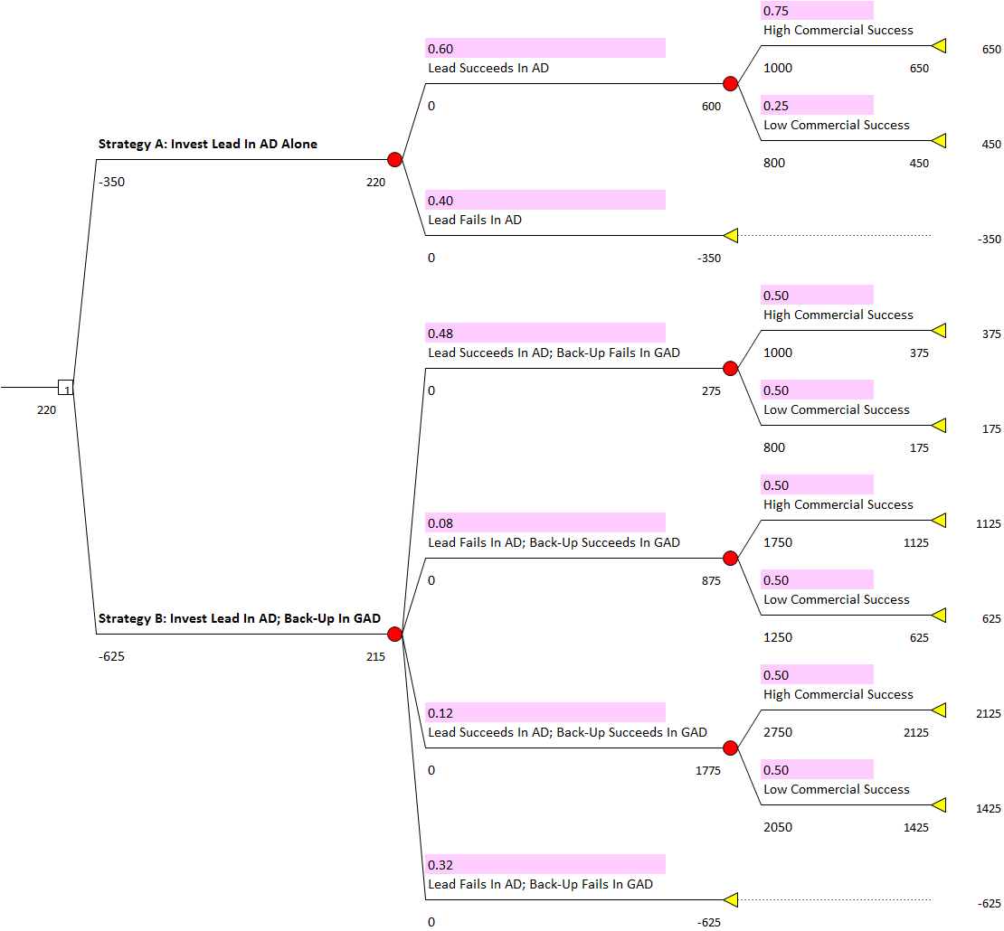

Figure 13-1 Decision Tree depicting technical and regulatory risks and commercial uncertainties associated with the pursuit of Strategy A (lead entity in pursuit of AD alone) and Strategy B (lead entity in pursuit of AD and back-up entity in pursuit of GAD)
On the basis of ENPV, the dominant decision is to pursue Strategy A (Invest lead entity in AD alone) as this yields $220M while the ENPV of Strategy B (Invest lead entity in AD and back-up entity in GAD) is $215M. However, given the level of investment necessary and the impact that judgmental risks and forecasted commercial valuations have on the dominant decision, it is instructive to interrogate the pedigree of the data before committing to a decision.
First and foremost, the probability of high commercial success of the lead entity in AD is estimated at 0.75. How sensitive is the dominant decision to this elicited probability? To answer the question, one can conduct a sensitivity analysis to the probability using Excel’s Solver function as shown in Figure 13-2 (Excel file: Drugs R Us; Tab 1-Way Prob Sens). By setting cell L1 as both the target cell and the changing (variable) cell, and maintaining cell B21 = 1 i.e. selecting Strategy A, one can see that at a probability value just below 0.71, the dominant decision switches from Strategy A to Strategy B (Figure 13-2; Excel file: Drugs R Us; Tab 1-Way Prob Sens).
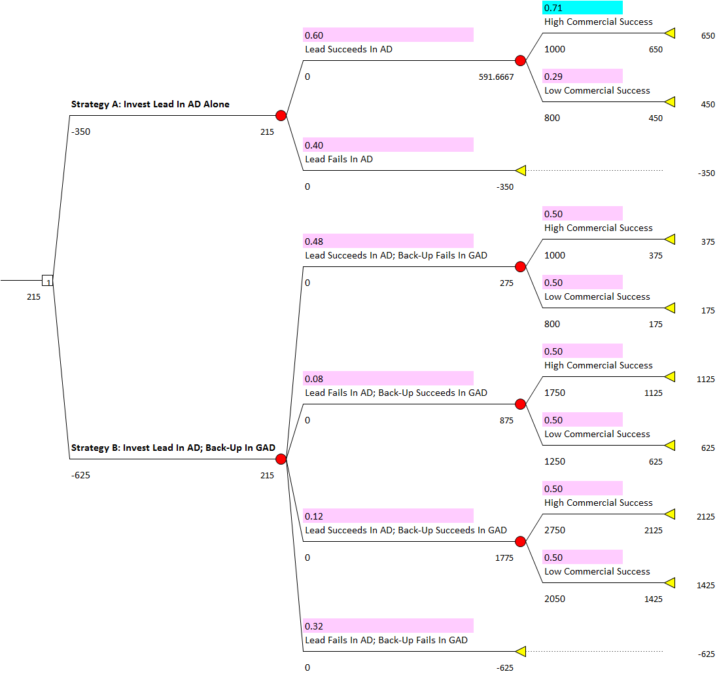
Figure 13-2 1-way sensitivity analysis to the probability of high commercial success of Strategy A (lead entity in pursuit of AD alone) and its impact on the dominant decision
Given the sensitivity of the dominant decision to the probability of high commercial success if Strategy A is pursued, what other risks may impact the dominant decision most? With the help of Excel’s Data Table function, one may examine concomitantly, the impact of the probabilities of high commercial success of the lead in AD alone and the lead and back-up entities and in AD and GAD. These results of such a 2-way sensitivity analysis to probabilities are shown in Table 13-2 (Excel file: Drugs R Us; Tab 2-Way Prob Sens) and are discussed in depth in Chapter 13.
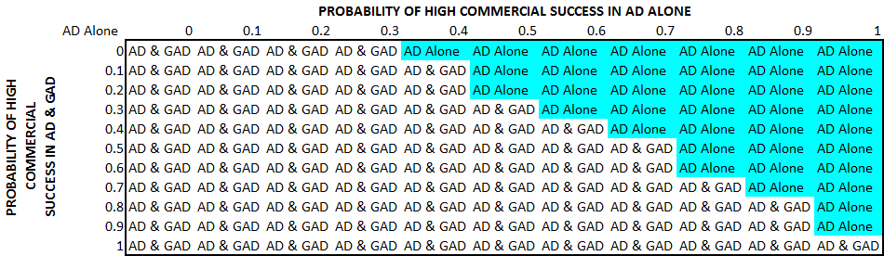
Table 13-2 2-way sensitivity analysis to the probabilities of high commercial success of Strategy A (lead entity in pursuit of AD alone) and Strategy B (lead entity in pursuit of AD and back-up entity in pursuit of GAD) and their impact on the dominant decision
In a similar vein, one may interrogate the sensitivities of commercial values (payoffs) of both strategies to the dominant decision. For example, a comparison of the concomitant sensitivities of high commercial values ranging from $850M to $1,250M in AD alone (Strategy A) and from $2,500M to $3,500M in AD and GAD (Strategy B) is shown in Table 13-3 (Excel file: Drugs R Us; Tab 2-Way Value) and is discussed in depth in Chapter 13.
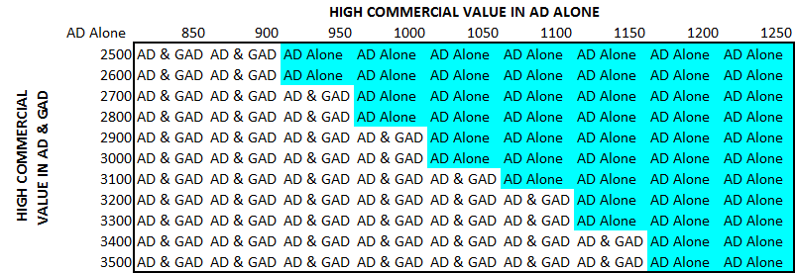
Table 13-3 2-way sensitivity analysis to high commercial values (payoffs) of Strategy A (lead entity in pursuit of AD alone) and Strategy B (lead entity in pursuit of AD and back-up entity in pursuit of GAD) and their impact on the dominant decision
Finally, one may examine the impact of risk and uncertainty in a similar analysis. In the example shown in Table 13-4, the probability of technical and regulatory success in AD alone (Strategy A) is compared alongside the high commercial value in AD and GAD (Strategy B) in terms of their impact on the dominant decision (Excel file: Drugs R Us; Tab 2-Way Prob + Value Sens) and is discussed in depth in Chapter 13.
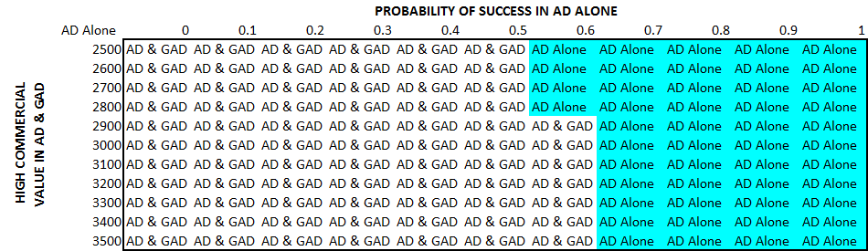
Table 13-4 2-way sensitivity analysis of the probability of technical and regulatory success in AD alone (Strategy A) and high commercial success in AD and GAD (Strategy B) and their impact on the dominant decision

