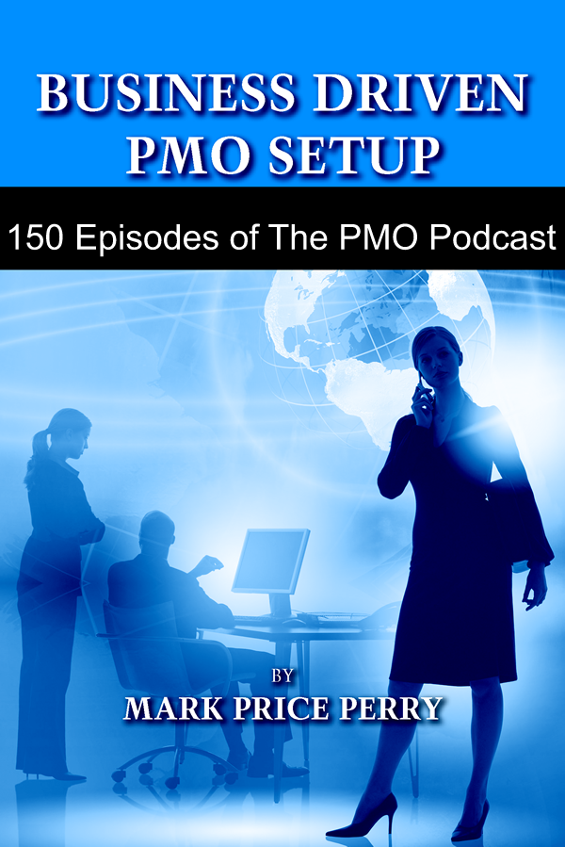

150 AUDIO CAST EPISODES OF THE PMO PODCAST™

The PMO Podcast™ can be found on Apple iTunes at:

https://podcasts.apple.com/us/podcast/the-pmo-podcast/id183040323

and at BOT International at:

http://www.botinternational.com/pmo-podcasts.html

The 150 audio cast episodes of The PMO Podcast™ provide valuable insights and ideas for today’s PMOs. Each episode provides fifteen minutes of topical information and consists of the following three segments:

- The PMO Podcast™ Memo

  - A short topic and opinion piece presented by the host of the show

- The PMO Podcast™ Featured Story of the Show

  - A featured presentation or guest interview

- The PMO Podcast™ Mailbag,

  - A question from a listener and answer by the show host

The PMO Podcast™
Episodes 1 – 150

To listen to a podcast, visit http://www.botinternational.com/pmo-podcasts.html

# Title of Episode Duration
001 Establishing a Culture of Continuous Improvement 10:45
002 Ten Project Rescue Tips for PMO Managers 11:22
003 Introduction to OPM3® , an interview with John Schlichter, OPM Experts 12:52
004 The Marketing PMO, an interview with Dave Larson, BOT International 11:01
005 Confucius Sayings for the PMO 10:38
006 Time Management Ideas for your Project Managers 9:55
007 Getting Started with Portfolio Management 11:36
008 The Wireless and Mobility PMO, an interview with Steve Jones, CEO PortNexus 13:19
009 Barriers to Project Negotiations 10:13
010 PMO Dashboards, an interview with Richard Eichen, CEO of Return on Efficiency 10:46
011 People Management Tips, an interview with John Chrystal, President of IDS Inc. 22:26
012 Demand Pull, an interview with Dave Larson, BOT International 12:39
013 PMO Mergers, an interview with Sarah Jane Sanders, BOT International 15:30
014 Developing your Project Managers, Five Skillsets to Hone 12:43
015 Requirements Definition, an interview with Jim Bowen, President OTPMS 13:06
016 Starting a PMO, an interview with Richard Eichen, CEO of Return on Efficiency 13:08
017 Project Management Methodology, a PMO Manager’s Perspective 11:13
018 Project Manager Performance Assessments that Motivate 13:25
019 2006 Trends and Insights, and interview with Dave Larson, BOT International 21:28
020 PPM Software-as-a-Service, an interview with Christian Smith, VP Sales, daptiv 20:33
021 PMO Outsourcing, “You know you are a services addict if?” 13:50
022 Project Fast Tracking: Part I - PMO Policy 13:59
023 Project Fast Tracking: Part II - Microsoft Project Tips 11:06
024 Proverbs for your PMO, Inspired by a Coral Snake 13:38
025 Project-ON-Demand, an interview with Marc O’Brien, CEO, Projity 17:11
026 Project Management Tips from the European Ryder Cup Team 15:59
027 Successful PM in Marketing Requires a PM Tool, Let Them Have One 11:33
028 Ten PMO Manager Tips for Project Management Vendors 13:19
029 Seven PMO Manager Ideas to Reduce IT Costs 14:28
030 Project Management in Kuwait, an interview with Randy Tangco, National Bank of Kuwait 18:34
031 The 7 Habits of Highly Effective IT Portfolio Management Implementations, an interview with 23:46
Gil Makleff, President, UMT Consulting Group North America
032 An Overview of Scrum for PMO Managers 11:46
033 An Overview and History of the Agile Manifesto 15:43
034 PMO Setup with Processes On Demand, an interview with Dave Larson, BOT International 19:44
035 Team Building: Part I - Tips for PMO Managers 12:18
036 Team Building: Part II - Tips for Team Members 12:53
037 Project Management in Singapore, an interview with Shane Conroy, Misys International 23:10
038 International Project Management, an interview with Shane Conroy, Misys International 23:51
039 Hosted or Installed PPM, @task Lets You Choose, an interview with Abraham Knell, 19:39
VP of Sales, @task
040 PMO Leadership: Dynamic Scheduling as a Key Business Skill 18:31
041 2006 Project Manager Salary Analysis and Recommendations for 2007 15:20
042 PMO Dashboarding with Processes On Demand, an interview with Dave Larson, 16:03
BOT International
043 Five Habits PMO Managers Like Their Project Managers to Have 12:44
044 Guiding the PMO Using a PPM Framework, an interview with Scott Hutchinson, 17:03
CEO of LucidPM
045 SugarCRM Defines the New CRM Generation, an interview with John Roberts, 29:39
CEO, SugarCRM
046 Ten Project Management Proverbs 9:48
047 Ten Suggestions for Project Management Maturity 12:05
048 ROI Model for your PMO Organizational Project Management Process Framework 14:51
049 Understanding Project Management for Those Outside the PMO 12:27
050 Effective Document Management Policies for your PMO 20:00
051 Top Three “Go-To-Market” Mistakes that Sales VPs Make, an interview with Dave Larson, 20:31
BOT International
052 Onsite Project Management Training for your PMO, an interview with Michelle LaBrosse, 16:59
CEO, Cheetah Learning
053 Seven Ways to Build PMO Awareness 13:53
054 Five Outsourcing Mistakes and the PM Challenges They Present 12:21
055 Recommendations for Informal Projects: Part I - The Simple WBS 12:23
056 Recommendations for Informal Projects: Part II - The Simple Dynamic Schedule 12:53
057 Recommendations for Informal Projects: Part III - Simple EVM 13:45
058 Recommendations for Informal Projects: Part IV - Risk Management 15:28
059 Recommendations for Informal Projects: Part V - Simple Status Reporting 12:37
060 Microsoft Office Project Portfolio Server 2007 FAQs 15:17
061 Stress in the PMO 12:05
062 Ten Things Bad Bosses Do 13:48
063 Ten Characteristics of Good PMO Leaders 14:08
064 ProjectReference - a Useful Reference Site for your PMO, an interview with John Musser, 14:19
Software Development SME
065 PMO 2.0 - Expanding Participation in PM throughout the Business 15:52
066 Tool Advice for Informal Project Managers - Look out for Outlook 14:49
067 PMO Studies: Part I - Top Three Mistakes PMO Consultants Make 14:42
068 PMO Studies: Part II - Top Three Home Runs PMO Consultants Hit 15:02
069 PMO Studies: Part III - Five Tips from CIOs for Setting Up a New PMO 19:17
070 PMO Studies: Part IV - Alternative PMO Models 18:28
071 PMO Studies: Part V - Position Description for the IT PMO Manager 16:27
072 PMO Studies: Part VI - Interviewing Project Managers for the PMO 13:36
073 PMO Studies: Part VII - Project Management Methodology Alternatives 19:51
074 PMO Studies: Part VIII - Portfolio Management Best Practices 17:42
075 PMO Studies: Part IX - Collaboration and Document Management Best Practices 18:31
076 PMO Studies: Part X - Project Rescue Best Practices 13:14
077 Project Kick-off Meeting Tips 12:02
078 How to Avoid Pouring Good Money into a Bad Project 12:52
079 The PMO Project Advocate, the Sixth Man on the Project Team 11:00
080 Is Project Management Right For You? 12:02
081 An Introduction to the Project Management Triple Constraints 11:19
082 Ten Arguments Against Having a PMO 14:25
083 Change Happens 12:00
084 Business Use Cases for PMO Processes and Policies 15:56
085 SugarCRM Sweetens Project Management, an interview with John Roberts, CEO, 26:58
and Chris Harrick, Director of Product Marketing
086 Convincing Executives on the Value of PMO Processes and Policies 17:03
087 The Hidden Cost of Project Management Training 18:19
088 Introduction to e-ProjectManagers.com, an interview with Dora Tarver, 20:53
Founder and PPM Consultant
089 An Introduction for Executives to the Project Management Institute 15:45
090 An Introduction for Executives to the Project Management Body of Knowledge 14:30
091 Eight Risk Management Survival Skills 14:13
092 Organizational Planning with a Responsibility Assignment Matrix 11:37
093 Punctuate PM with a Post-Closing Continuous Improvement Process 11:08
094 Activity Sequencing Best Practices 10:32
095 Risk Management Planning Strategies 13:18
096 The PMO Summit 2007, an interview with Marie-Louise Adlercreutz, Director, IQPC 10:29
097 Is the Work Breakdown Structure Over-Rated? 9:29
098 Three Reasons to Have a Continuous Improvement Process Step 12:37
099 Encourage Reporting of Bad News 11:46
100 Project Portfolio Management Deployment Guidelines, an interview with Dr. Ginger Levin 22:44
101 Project Delivery Group or PMO, an interview with Richard Eichen, 12:30
CEO of Return on Efficiency
102 Project Selection Scorecarding for the Small PMO 14:20
103 Ten Tips for Holding Project Team Members Accountable 12:22
104 The PMO Summit 2007,an interview with Marie-Louise Adlercreutz, Director, IQPC 12:36
105 New Directions and Innovations in Metrics-Based Management, 21:19
an interview with Dr. Ginger Levin
106 Factors Influencing Technology Adoption, an interview with Dr. Craig Van Slyke, 19:26
University of Central Florida
107 Project Management in Brazil, an interview with Cicero Ferreira, 17:08
President of Omega Consultoria
108 Implementing Process Improvement as a PMO Best Practice, 16:15
an interview with Michael Wood, President of The Natural Intelligence Group
109 Introducing ConceptDraw Project 3, an interview with Olin Reams, 19:41
General Manager Americas for Computer Systems Odessa
110 Integrating Project Management with Email, an interview with Andrew Filev, 15:23
Founder and President of Wrike
111 Projity Announces OpenProj, the Open Source Replacement of Microsoft Project, 11:01
an interview with Marc O'Brien, CEO of Projity, Inc.
112 The Value of Project Management 16:35
113 Top 10 Benefits of Project Server 13:33
114 How Not to Rescue a Failing Project 14:12
115 How to be a Good Project Manager 12:21
116 Seven Tips for Running Effective Project Meetings 12:12
117 Process Configuration vs. Methodology Development 16:53
118 Don't Assume Project Managers are Good PMO Team Players, 15:11
an interview with Ron Anderson, President of The MTC Firm
119 The Evolution of eProject to Daptiv, an interview with Christian Smith, 18:04
VP of Sales and Marketing, Daptiv
120 The 2007 Top Ten PMO Setup Tips 14:51
121 PPM Software as a Service, an interview with Greg Tilley, 23:57
Manager of Business Development, VCS Online
122 Fiddler on the Project, an interview with Rich Maltzman, PMP 16:55
123 PMO Models: Are they emphasized too much? 9:00
124 PMO 2.0, an interview with Terry Doerscher, Chief Process Architect, Planview 40:13
125 Online Project Management Solutions for Everyone, an interview with Brandon Baker, 10:44
Solutions Specialist, EPM Live
126 International Project Manager Travel Survival Tips 15:09
127 Process Lessons Learned from Singapore Airlines 13:30
128 Do you have a PMO Architecture? 12:45
129 What are PMO Content Assets? 17:54
130 People Management Tips for the PMO 12:31
131 Enterprise Project Management with Microsoft Project Server, 22:45
an interview with Tony Zink, EPM Subject Matter Expert, with MSProjectExperts
132 Introducing 5pm, a next generation PM tool, 15:12
an interview with Sergei Podbereschi, co-founder of QG Software
133 How to Encourage Bright Ideas 12:55
134 How to Develop a Strategic Plan for the PMO 15:21
135 Establishing a Community of Practice in 7 Easy Steps, 23:45
an interview with Andrew Makar, SME, Gantthead.com
136 The PMO Summit 2008, an interview with Marie-Louise Adlercreutz, Director, IQPC 15:21
137 Top 10 Tips for PMO Setup 15:21
138 Top 10 Tips for a PPM Software Selection Project 14:09
139 Top 10 Tips for Justifying an EPM Tool 14:27
140 Top 10 Tips for Evaluating SaaS 14:05
141 Top 10 Tips for Project Portfolio Management 14:40
142 Top 10 Tips for Microsoft Project Server 12:37
143 Top 10 Tips for Microsoft SharePoint 14:50
144 Top 10 Tips for Managing PMO Processes 13:02
145 Top 10 Tips for Avoiding Project Failure 14:03
146 Top 10 Tips for Continuous Improvement 14:45
147 Top 10 Tips for Managing Your Peers 14:03
148 Top 10 Tips for People Accountability 14:37
149 Top 10 Tips for “Go-to-Market” Projects 13:01
150 Top 10 Tips for Project Management Vendor Presentations 14:03

