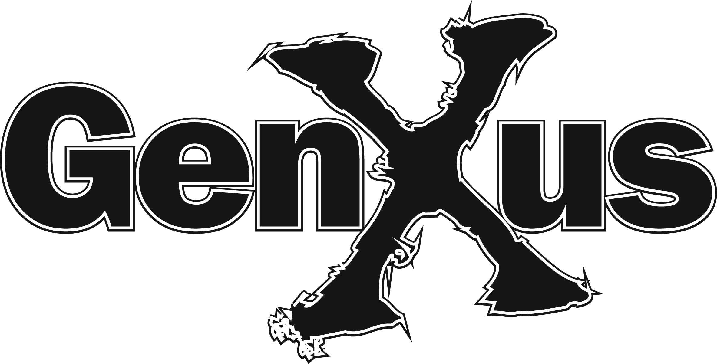

Agile Triage Checklist

Author: Kevin Aguanno, Agile Consultant
Phone: (416) 540-8570
Email: kevin@AgilePM.com

Introduction
To determine if an agile approach is suitable for your project, the project manager (representing the project delivery team) and the project sponsor (possibly with the support of a business analyst who understands the project’s business case) will need to discuss the following questions.
Questions are grouped into three areas. The first area considers questions about the sponsoring organization’s readiness to adopt an agile approach. The second area looks at the characteristics of the candidate project to see if an agile approach is feasible. The third area examines the impacts of an agile approach on staffing.

How to Use This Checklist
Generally, the answer to each question should be “Yes” or positive. “No” answers are allowed, but the more negative responses there are, the more the sponsor and project manager should consider adopting the waterfall-based model as the more appropriate choice. Sometimes, a “No” answer may be acceptable as the individual criterion may not be relevant to a particular project. Other times, a “No” answer may be accompanied by a strategy for addressing the risk that a “No” answer raises.

Organizational Considerations
Item | Description | Response: “Yes” or “No”  (“No” responses should include a comment on relevance or strategy to address risks)
Single Sponsor | The project should have a single responsible sponsor. If a larger group of stakeholders is involved, the sponsor will be the representative of that group and will be able to make day-to-day project decisions. The sponsor may further delegate some decision-making responsibility to a business subject matter expert who may have more hands-on involvement in the project.
Sponsor has Completed Agile Core Training | The role of the business sponsor (and any delegate) is different under the agile delivery model than in the waterfall-based enterprise delivery framework. Sponsors must have completed the Executive Agile Training course from explaining how the sponsor’s role changes under the agile model.
Willingness to Commit | Sponsoring and participating organizations must be willing to commit to embrace fully the agile approach.
Willingness to Make Decisions | The sponsor must be willing to make quick decisions during the course of the project. Agile projects often fail when sponsors have to go back to working groups or steering committees to obtain a consensus before delivering an answer to the project team.
Willingness to Be Accountable | In an agile project, sponsors have more control over the project than in the waterfall-based enterprise delivery framework; however, this control comes with more responsibility and accountability. The sponsor must be willing to be accountable along with the rest of the project team for the success of the project.
Availability | Since the agile model does not complete all requirements and design work at the start of the project, the team will need access to the sponsor (or a delegate) throughout the project for decision making, escalations, and incremental approvals.
Flexible Funding Model | The funding organization recognizes that original estimates are high level and are based upon a limited understanding of the solution. These should be range estimates that allow for variance. Funding requirements will be refined and the range narrowed in stages during the project.

Project Considerations
Item | Description | Response: “Yes” or “No”  (“No” responses should include a comment on relevance or strategy to address risks)
Containable Risk | Mission-critical projects are not best suited to an agile approach due to the lack of up front analysis and evolutionary design that may miss key functional or non-functional requirements that could have a significant impact if the solution is put into operation. Agile methods are so focused on functional delivery that there is a risk that critical non-functional requirements may get deprioritized or missed altogether. The more rigorous up-front review and signoff processes in the waterfall-based delivery framework reduce the risk of missing these requirements.
Moderate to High Level of Change | It is expected that the project will experience a moderate to high level of change. Change could be driven by changing sponsorship or executive support, poorly-defined or incomplete requirements, requirements change, technical uncertainty, lack of experienced/skilled resources, and others.
Flexible Scope | High levels of change typically involve scope change, rather than budget or timeline changes. Agile projects successfully manage fixed price and fixed timeline projects by varying the scope to maintain the other two parameters. (For fixed scope projects, one of the other parameters needs to vary: typically, budget. This option is less commonly found on agile projects.)
Success or Acceptance Criteria Well-Defined | Initial or high-level requirements have clearly-defined acceptance or success criteria.
Business-Case Driven | Can the project's expected results be tied directly to a business case? Agile projects prioritize their work to deliver business value early in the project. To help the team prioritize their work, the sponsor will need to understand the project business case and the relative value of delivering some solution components earlier than others.
Requirements Management Tool | Agile projects tend to experience a relatively high level of requirements change. Managing the impacts of the changes is difficult without the use of some form of requirements management tool to maintain control and traceability. Requirements management tools can be formal packages or they can be informal such as Excel spreadsheets. The team needs to choose a tool that is right-sized for the size of the project and that takes into account whether the team is collocated or distributed.
Enhanced Level of Quality | The agile model is focused on quality. Under this model, testing happens throughout the project lifecycle leaving more time to find and fix defects than in the waterfall-based model. This will result in a higher quality product, but requires a different level of investment in quality-related infrastructure and activities. Does the business case demand this enhanced level of quality?
Testing Infrastructure | With testing happening throughout the project lifecycle, the project team will need access to a test environment throughout the life of the project. This environment may be dedicated or shared; however shared test environments may increase coordination efforts and impact test and defect resolution efforts due to cross-project impacts within the shared environment. Will the team have access to a test environment throughout the project?
Test Management Tool | To manage the higher volume of testing, it is highly recommended that teams use a test management tool such as HP Quality Centre.
Automated Testing Tool | With regression testing happening in every iteration during the construction phase of the project, the workload for testers rapidly increases until maintaining code coverage is no longer feasible. Automated testing tools solve this problem. By converting from manual to automated testing, the retesting effort is dramatically reduced, often achieving payback on the automation effort within two test iterations.

Staffing Considerations
Item | Description | Response: “Yes” or “No”  (“No” responses should include a comment on relevance or strategy to address risks)
Single Project Assignment | In an agile delivery model, an individual's productivity is significantly lowered by interruptions associated with working on multiple projects. Where feasible, core team members should be assigned full time to the project, with part-time assignments reserved for supporting roles.
Cross-Discipline Approach | To achieve the highest levels of performance, team members must work together to achieve shared goals. A silo mentality within the team significantly reduces productivity and increases the incident of handoff-related issues. Team members must collaborate effectively across traditional role boundaries for project success.
Efficient Communication | The most efficient communications are face to face with collocated teams. If this is not feasible, team members should have access to collaboration tools to improve communications efficiency. Tools should include teleconferencing, instant messaging, screen sharing, and virtual whiteboarding tools. Additional options include collaborative documentation development tools (such as wikis) and online project document repositories.
Experience | In the agile delivery model, design activities are spread throughout the project. Since all of the design is not completed up front, the project requires skilled, experienced team members in key lead roles on the team who can use their tacit knowledge and experience to avoid pitfalls and to avoid risks.
Team Members have Completed Agile Training | To function effectively within the agile delivery model, team members must have completed the agile introductory training as well as supplemental training appropriate for their role.
Agile Coaching | To shorten the time to achieving value and to avoid repeating common mistakes, teams that are new to agile should have an experienced agile coach to help them through the initial organization of their project with ongoing part time support to help address any questions that may arise over the course of the project. Experienced agile teams should be able to execute their project without the need for an agile coach.
Tolerance for Ambiguity | Early in a relatively high-change project, team members need to be able to tolerate some level of ambiguity (such as in requirements or design) and resulting risk in order to be effective. The level of ambiguity and risk will reduce as the project progresses.
PM Leadership Style | The least effective leadership style in an agile project is the command-and-control model. To be most effective, the PM assigned to the project should use a servant-leader model where the PM recognizes that the team members are the ones creating business value and the PM exists to facilitate value delivery by removing barriers for the team.

